const express=  require('express')

const app =  express()

app.get('/',(req,res,next)=>{

    res.send("hello")

})

app.listen(3000)

Check localhost:3000

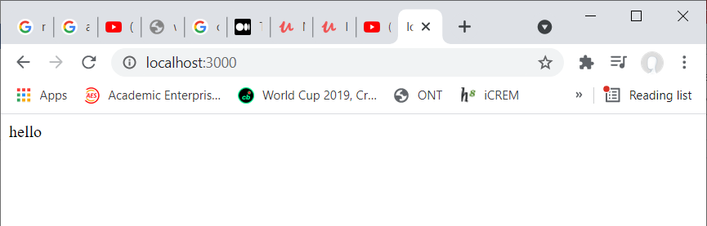

const express=  require('express')

const app =  express()

app.get('/',(req,res,next)=>{

    res.send("hello")

})

app.get('/json',(req,res,next)=>{

    const data ={

        greeting:'Hello'

    }

    res.json(data)

})

app.listen(3000)

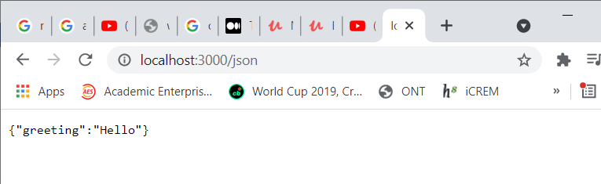

const express=  require('express')

const path=require('path')

const hoganMiddeleware=require('hogan-middleware')

const app =  express()

app.set('views',path.join(__dirname,'views'))

app.set('view engine', 'mustache')

app.engine('mustache', hoganMiddeleware.__express)

app.get('/',(req,res,next)=>{

    res.send("hello")

})

app.get('/json',(req,res,next)=>{

    const data ={

        greeting:'Hello'

    }

    res.json(data)

})

app.get('/home',(req,res,next)=>{

    res.render('home',null)

})

app.listen(3000)

**home.mustache**

<html>

<head>

</head>

<body>

<h1> This is home page</h1>

</body>

</html>

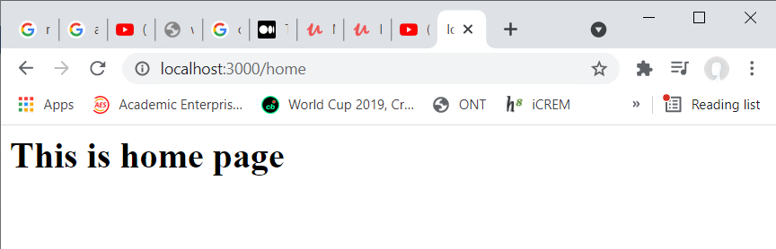

Mkdir public

Cd public

Mkdir images

Mkdir css

Mkdir js

Add image into public/images

Add css file style.css in public/css

const express=  require('express')

const path=require('path')

const hoganMiddeleware=require('hogan-middleware')

const app =  express()

app.set('views',path.join(__dirname,'views'))

app.set('view engine', 'mustache')

app.engine('mustache', hoganMiddeleware.__express)

app.use(express.static(path.join(__dirname,'public')))

 app.get('/',(req,res,next)=>{

     res.send("hello")

})

 app.get('/json',(req,res,next)=>{

     const data ={

         greeting:'Hello'

     }

     res.json(data)

 })

 app.get('/home',(req,res,next)=>{

     res.render('home',null)

 })

app.listen(3000)

console.log("server running in https://localhost:3000")

<html>

<head>

<link rel="stylesheet" type="text/css" href="/css/style.css">

</head>

<body>

<h1> This is home page</h1>

<img src="images/download.jfif"/>

</body>

</html>

h1

{

    color: red;

}

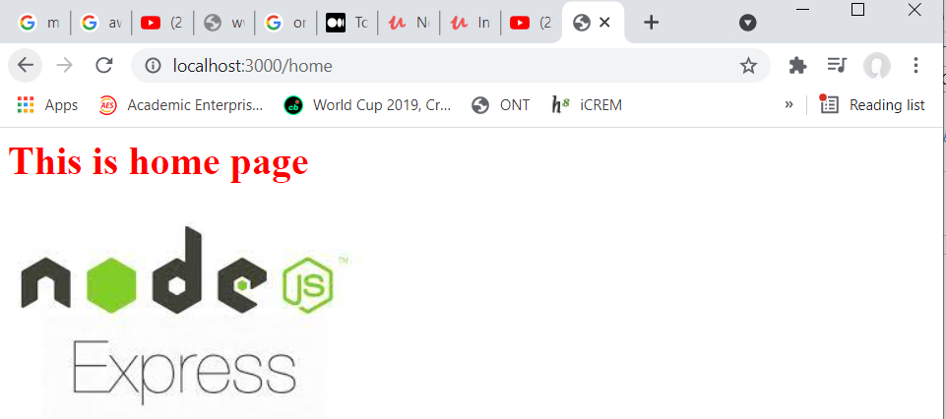

Mkdir routes

Cd routes

Create index.js

Index.js in node1/routes/index.js

const express= require('express')

const router=express.Router()

router.get('/',(req,res,next)=>{

    res.send('Hello World from routs')

})

router.get('/home',(req,res,next)=> {

    res.render('home',null)

})

router.get('/json',(req,res,next)=>{

    res.json({

        greetings:"Hello from json in routes"

    })

})

module.exports= router

index.js in node1/index.js

const express=  require('express')

const path=require('path')

const hoganMiddeleware=require('hogan-middleware')

const app =  express()

app.set('views',path.join(__dirname,'views'))

app.set('view engine', 'mustache')

app.engine('mustache', hoganMiddeleware.__express)

app.use(express.static(path.join(__dirname,'public')))

const indexRouter=require('./routes/index')

app.use('/',indexRouter)

app.listen(3000)

console.log("server running in https://localhost:3000")

Project Generators:

Npm install turbo-cli –g

Check version

Turbo version

Create sample

Turbo new sample_project

Sample project created

Project structure created with public routes package and app.js we will get fully functional project here

Cd sample_project

Now when we check json many dependencies are there to install them

Npm install

All will be installed and folder node_modules will be creted

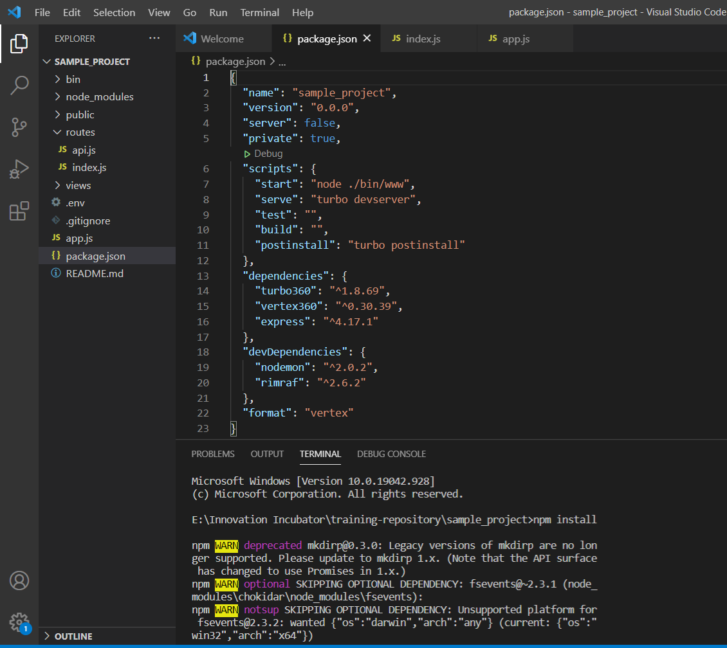

To check whether its running

Use

Nodemon

Localhost:3000

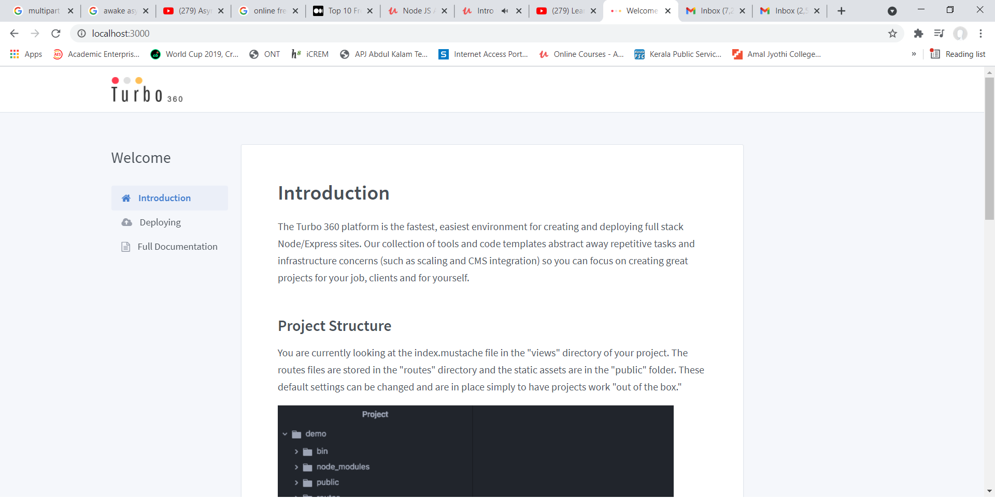

Index.js

// Full Documentation - https://docs.turbo360.co

const express = require('express')

const router = express.Router()

/*  This is the home route. It renders the index.mustache page from the views directory.

  Data is rendered using the Mustache templating engine. For more

  information, view here: https://mustache.github.io/#demo */

router.get('/', (req, res) => {

  res.render('index', { text: 'This is the dynamic data. Open index.js from the routes directory to see.' })

})

router.get('/:path',(req,res)=>{

  const path=req.params.path

  res.json({

    data:path

  })

})

router.get('/:profile/:username',(req,res)=>{

  const profile=req.params.profile

  const username=req.params.username

  res.json({

    Id:profile,

    name:username

  })

})

module.exports = router

nodemn

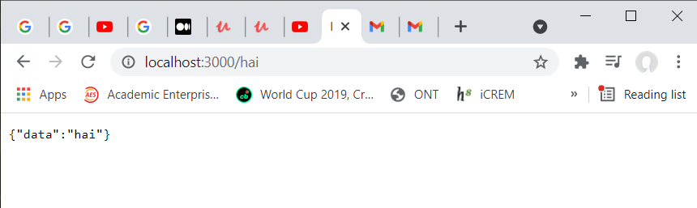

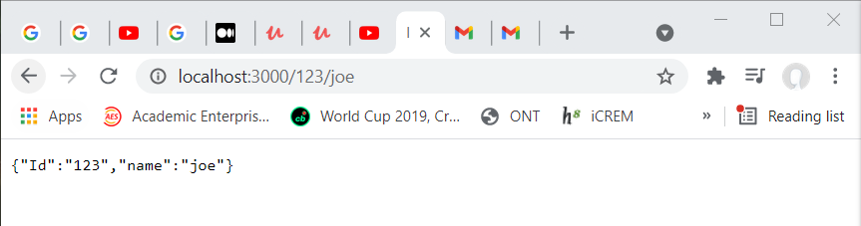

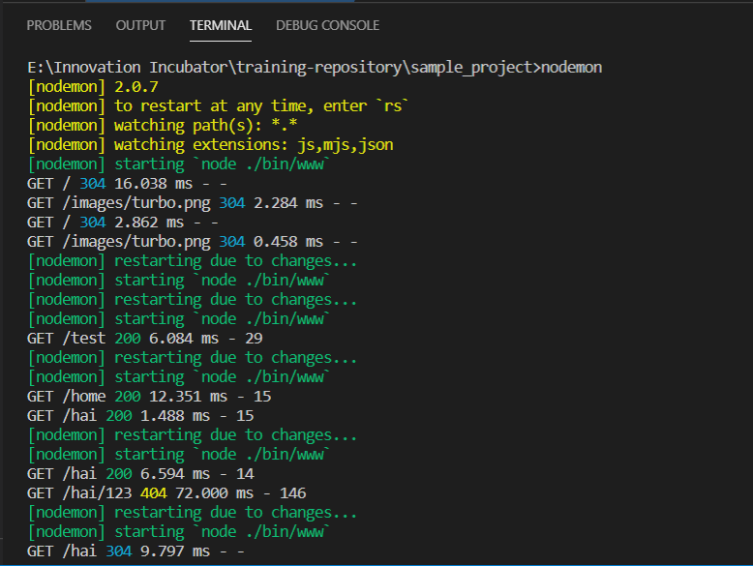

const express = require('express')

const router = express.Router()

router.get('/', (req, res) => {

  res.render('index', { text: 'This is the dynamic data. Open index.js from the routes directory to see.' })

})

router.get('/query',(req,res)=>{

  const name=req.query.name

  const occupation=req.query.occupation

  res.json({

    name:name,

    occupation:occupation

  })

})

router.get('/:path',(req,res)=>{

  const path=req.params.path

  res.json({

    data:path

  })

})

router.get('/:profile/:username',(req,res)=>{

  const profile=req.params.profile

  const username=req.params.username

  res.json({

    Id:profile,

    name:username

  })

})

module.exports = router

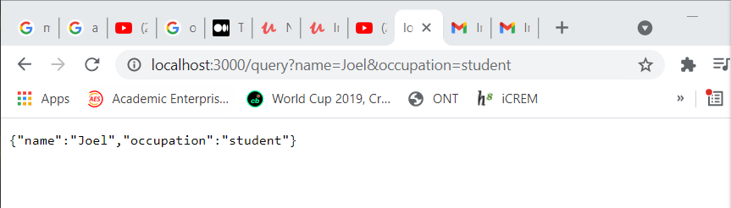

Display data in another page: routes/index.js

const express = require('express')

const router = express.Router()

router.get('/', (req, res) => {

  res.render('index', { text: 'This is the dynamic data. Open index.js from the routes directory to see.' })

})

router.get('/query',(req,res)=>{

  const name=req.query.name

  const occupation=req.query.occupation

  const data={

    name:name,

    occupation:occupation

  }

  res.render('profile',data)

})

module.exports = router

views/profile.mustache

<html>

<head>

</head>

<body>

<h1>Name:{{name}}</h1>

<h2>Occupation:{{occupation}}</h2>

</body>

</html>

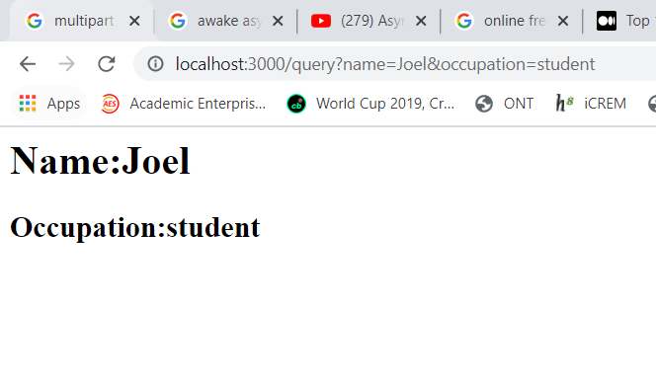

Post request to fetch data from form and display

// Full Documentation - https://docs.turbo360.co

const express = require('express')

const router = express.Router()

/*  This is the home route. It renders the index.mustache page from the views directory.

  Data is rendered using the Mustache templating engine. For more

  information, view here: https://mustache.github.io/#demo */

router.get('/', (req, res) => {

  res.render('index', { text: 'This is the dynamic data. Open index.js from the routes directory to see.' })

})

router.post('/post',(req,res)=>{

  const body=req.body

  res.json({

    conformation:'success',

    data:body

  })

})

module.exports = router

index.mustache

<!DOCTYPE html>

<html dir="ltr" lang="en-US">

<head>

<meta charset="UTF-8">

<meta name="viewport" content="width=device-width, user-scalable=no, initial-scale=1.0, maximum-scale=1.0, minimum-scale=1.0">

<title>Welcome to Turbo 360</title>

<link rel="shortcut icon" href="https://lh3.googleusercontent.com/MpnmfR3zYPTojA03QbhGgwIHucmH5s4G2vbIlADYhODL488MQt_BuVztv9LYmJbhwkScYN0DIXuh4d10YMsLbWXT">

<link rel="stylesheet" href="https://maxcdn.bootstrapcdn.com/font-awesome/4.7.0/css/font-awesome.min.css">

<link rel="stylesheet" href="https://fonts.googleapis.com/css?family=Source+Sans+Pro:300,300i,400,400i,500,500i,600,600i,700,700i&amp;subset=latin-ext">

<link rel="stylesheet" href="https://cdn.turbo360-dev.com/admin/assets/scaffold/css/style.min.css" />

</head>

<body>

<div class="container">

<div class="root">

<div class="col-md-10" style="text-align:center;margin-bottom:48px;">

<h1> Welcome</h1>

<hr/>

<div style="background:#f9f9f9;border:1px;solid:#ddd;border-radius:3px;">

<form action="/post" method="POST">

<div class="row">

<div class="col-sm-4">

<label>Enter Name</label></div><div class="col-sm-5"><input type="text" name="name"/></div></div>

<div class="row">

<div class="col-sm-4"><label>Enter Occupation</label></div><div class="col-sm-5"><input type="text" name="occupation"/></div></div>

<div class="row">

<div class="col-sm-3"></div><div class="col-sm-2"> <input type="submit" value="Submit"/></div></div>

</form>

</div>

</div>

</div>

</div>

</body>

</html>

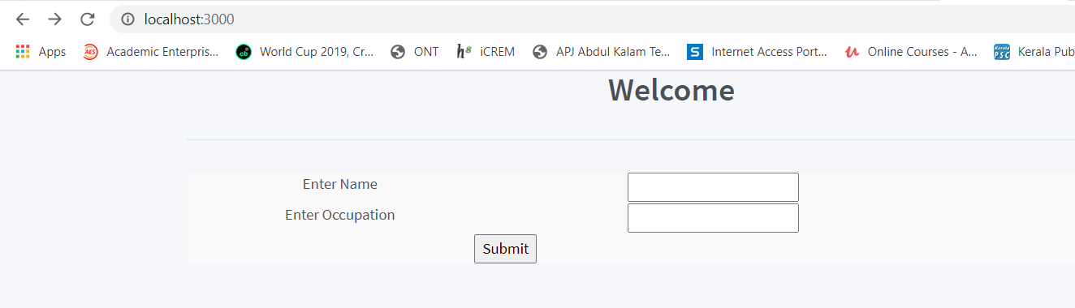

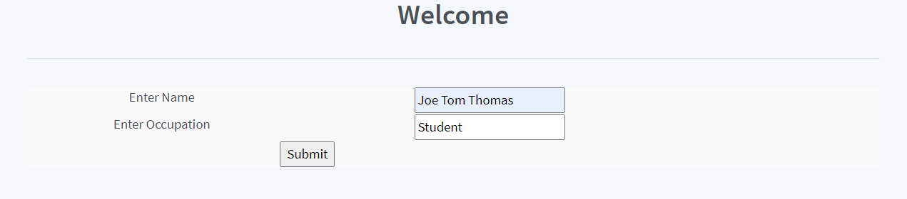

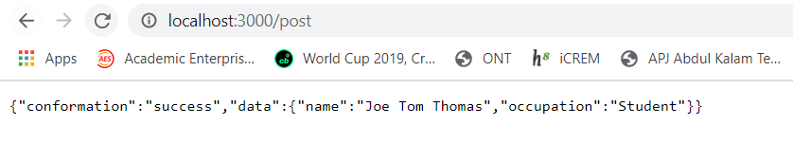

Trying reg by adding register in routes

Add register.js in routes

const express = require('express')

const router = express.Router()

router.post('/user',(req,res)=>{

    const body=req.body

    res.json({

        confirmation:"Success",

        route:"register",

        data:body

    })

})

module.exports = router

make changes in../app.js

const vertex = require('vertex360')({ site_id: process.env.TURBO_APP_ID })

const express = require('express')

const app = express() // initialize app

const config = {

  views: 'views', // Set views directory

  static: 'public', // Set static assets directory

  logging: true,

}

vertex.configureApp(app, config)

// import routes

const index = require('./routes/index')

const register = require('./routes/register')

// set routes

app.use('/', index)

app.use('/register',register)

module.exports = app

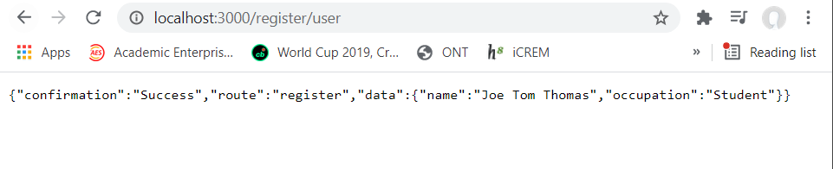

Creating profile and display

const express = require('express')

const router = express.Router()

const profiles={

  joe35:{

    name:'Joe Tom',

    company:'IIM',

    language:['js','Python','c++']

  },

  jubin36:{

    name:'Jubin Shaji',

    company:'TCS',

    language:['js','Python','C']

  },

  justine37:{

    name:'Justine Joseph',

    company:'Infosys',

    language:['Java','Python','c++']

  }

}

router.get('/:profile/:username',(req,res)=>{

  const profile=req.params.profile

  const username=req.params.username

  const profilenm=profiles[username]

  if(profilenm ==null){

    res.json({

      confirmation:'fail',

      message:'profile '+username +' not valid!!'

    })

  }

  res.json({

    Id:profilenm,

  })

})

module.exports = router

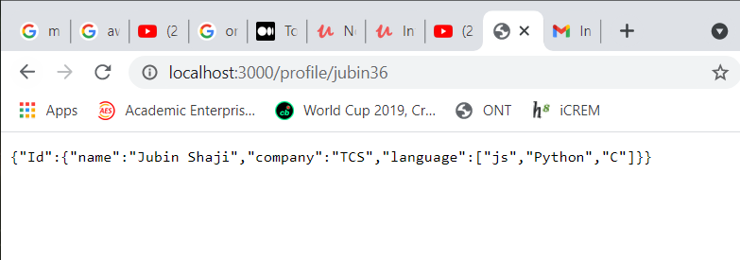

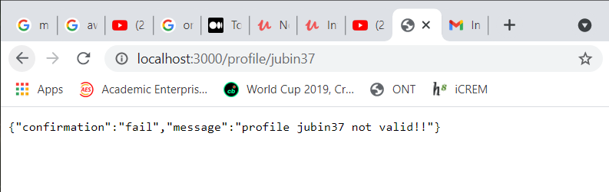

Pass values to another page:

<html>

<head>

</head>

<body>

<h1>Name:{{name}}</h1>

<h2>Company:{{company}}</h2>

</body>

</html>

const express = require('express')

const router = express.Router()

const profiles={

  joe35:{

    name:'Joe Tom',

    company:'IIM',

    language:['js','Python','c++']

  },

  jubin36:{

    name:'Jubin Shaji',

    company:'TCS',

    language:['js','Python','C']

  },

  justine37:{

    name:'Justine Joseph',

    company:'Infosys',

    language:['Java','Python','c++']

  }

}

router.get('/:profile/:username',(req,res)=>{

  const profile=req.params.profile

  const username=req.params.username

  const profilenm=profiles[username]

  if(profilenm ==null){

    res.json({

      confirmation:'fail',

      message:'profile '+username +' not valid!!'

    })

  }

  res.render('profile',profilenm)

})

module.exports = router

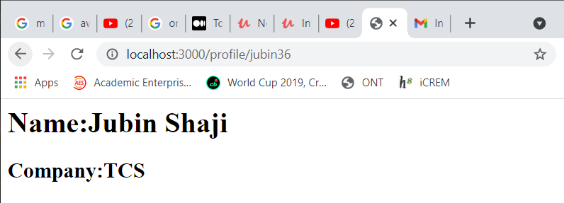

Add new profile using form:

Profile.mustache

<html>

<head>

</head>

<body>

<h1>Name:{{name}}</h1>

<h2>Company:{{company}}</h2>

<h3>Languages</h3>

<ol>

{{#language}}

<li>

{{.}}

</li>

{{/language}}

</ol>

<form action="/addprofile" method="post">

<input type="text" name="name" placeholder="Name"/><br/>

<input type="text" name="username" placeholder="Username"/><br/>

<input type="text" name="company" placeholder="company"/><br/>

<input type="text" name="language" placeholder="Languages"/><br/>

<input type="submit" value="add profile"/>

</form>

</body>

</html>

Index.js

const express = require('express')

const router = express.Router()

const profiles={

  joe35:{

    name:'Joe Tom',

    company:'IIM',

    language:['js','Python','c++']

  },

  jubin36:{

    name:'Jubin Shaji',

    company:'TCS',

    language:['js','Python','C']

  },

  justine37:{

    name:'Justine Joseph',

    company:'Infosys',

    language:['Java','Python','c++']

  }

}

router.post('/addprofile',(req,res)=>{

  const body=req.body

  body['language']=req.body.language.split(",")

  profiles[body.username]=body

  res.redirect('/profile/'+body.username)

})

router.get('/:profile/:username',(req,res)=>{

  const profile=req.params.profile

  const username=req.params.username

  const profilenm=profiles[username]

  if(profilenm ==null){

    res.json({

      confirmation:'fail',

      message:'profile '+username +' not valid!!'

    })

  }

  res.render('profile',profilenm)

})

module.exports = router

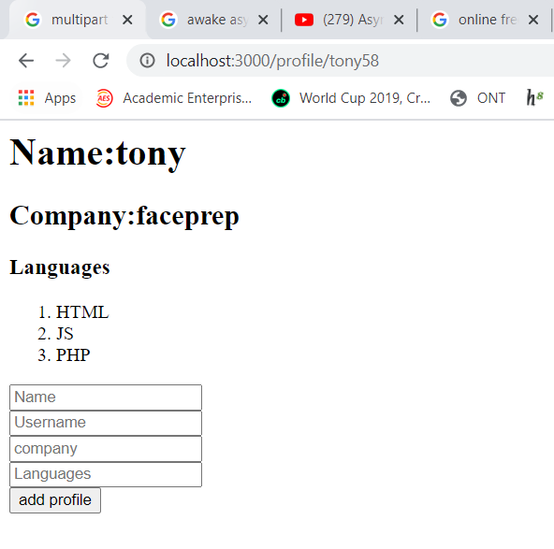

Add image and css

<html>

<head>

<link rel="stylesheet" href="/css/bootstrap.css" type="text/css"/>

<link rel="stylesheet" href="/css/style.css" type="text/css"/>

</head>

<body>

<div class="container">

<img class="profile-image" src="{{image}}"/>

<h1>{{name}}</h1>

<h2>Company:{{company}}</h2>

<h3>Languages</h3>

<ol>

{{#language}}

<li>

{{.}}

</li>

{{/language}}

</ol>

<form action="/addprofile" method="post">

<input type="text" name="name" placeholder="Name"/><br/>

<input type="text" name="image" placeholder="Image(/images/example.jpg)"/><br/>

<input type="text" name="username" placeholder="Username"/><br/>

<input type="text" name="company" placeholder="company"/><br/>

<input type="text" name="language" placeholder="Languages"/><br/>

<input type="submit" value="add profile"/>

</form>

</div>

</body>

</html>

Style.css

h1{

    color:red;

    text-transform: capitalize;

}

.profile-image{

    max-width:360px;

    max-height: 300px;

}

Index.js

const express = require('express')

const router = express.Router()

const profiles={

  joe35:{

    image:'/images/download.jfif',

    name:'Joe Tom',

    company:'IIM',

    language:['js','Python','c++']

  },

  jubin36:{

    image:'/images/download (1).jfif',

    name:'Jubin Shaji',

    company:'TCS',

    language:['js','Python','C']

  }

}

router.post('/addprofile',(req,res)=>{

  const body=req.body

  body['language']=req.body.language.split(",")

  profiles[body.username]=body

  res.redirect('/profile/'+body.username)

})

router.get('/:profile/:username',(req,res)=>{

  const profile=req.params.profile

  const username=req.params.username

  const profilenm=profiles[username]

  if(profilenm ==null){

    res.json({

      confirmation:'fail',

      message:'profile '+username +' not valid!!'

    })

  }

  res.render('profile',profilenm)

})

module.exports = router

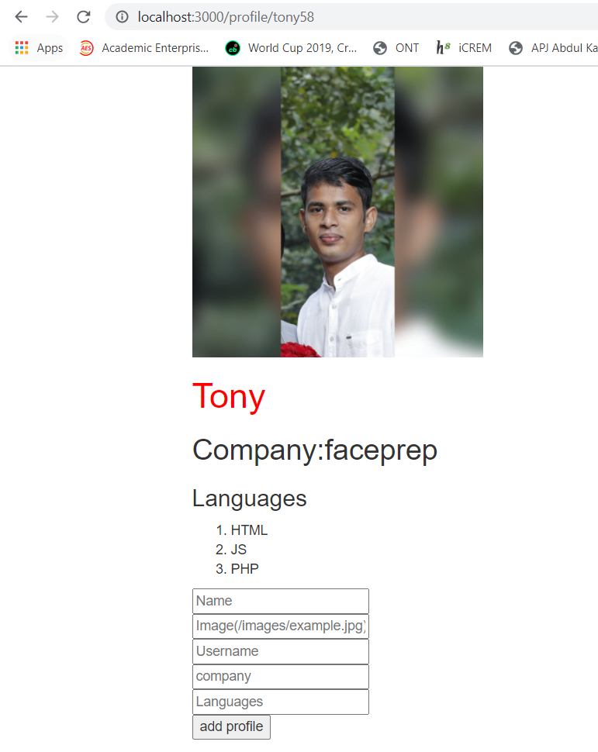

Profile.mustache

<html>

<head>

<link rel="stylesheet" href="/css/bootstrap.css" type="text/css"/>

<link rel="stylesheet" href="/css/style.css" type="text/css"/>

</head>

<body>

<span>{{timestamp}}</span>

<div class="container">

<img class="profile-image" src="{{image}}"/>

<h1>{{name}}</h1>

<h2>Company:{{company}}</h2>

<h3>Languages</h3>

<ol>

{{#language}}

<li>

{{.}}

</li>

{{/language}}

</ol>

<form action="/addprofile" method="post">

<input type="text" name="name" placeholder="Name"/><br/>

<input type="text" name="image" placeholder="Image(/images/example.jpg)"/><br/>

<input type="text" name="username" placeholder="Username"/><br/>

<input type="text" name="company" placeholder="company"/><br/>

<input type="text" name="language" placeholder="Languages"/><br/>

<input type="submit" value="add profile"/>

</form>

</div>

</body>

</html>

Profiles.mustache

<html>

<head>

<link rel="stylesheet" href="/css/bootstrap.css" type="text/css"/>

<link rel="stylesheet" href="/css/style.css" type="text/css"/>

</head>

<body>

<div class="container">

<span>{{timestamp}}</span>

<h1>Profiles</h1>

<ol>

{{#profiles}}

<li><a href="/profile/{{username}}">{{name}}</a></li>

{{/profiles}}

</ol>

<form action="/addprofile" method="post">

<input type="text" name="name" placeholder="Name"/><br/>

<input type="text" name="image" placeholder="Image(/images/example.jpg)"/><br/>

<input type="text" name="username" placeholder="Username"/><br/>

<input type="text" name="company" placeholder="company"/><br/>

<input type="text" name="language" placeholder="Languages"/><br/>

<input type="submit" value="add profile"/>

</form>

</div>

</body>

</html>

Index.js

const express = require('express')

const router = express.Router()

const profiles={

  joe35:{

    username:'joe35',

    image:'/images/download.jfif',

    name:'Joe Tom',

    company:'IIM',

    language:['js','Python','c++']

  },

  jubin36:{

    username:'jubin36',

    image:'/images/download (1).jfif',

    name:'Jubin Shaji',

    company:'TCS',

    language:['js','Python','C']

  }

}

  router.get('/', (req, res) => {

  res.render('index', { text: 'This is the dynamic data. Open index.js from the routes directory to see.' })

})

// router.post('/post',(req,res)=>{

//   const body=req.body

//   res.json({

//     conformation:'success',

//     data:body

//   })

// })

router.get('/profiles',(req,res)=>{

  const keys=Object.keys(profiles)

  const list=[]

  keys.forEach(key=>{

    list.push(profiles[key])

  })

  const data={

    profiles:list,

    timestamp:req.timestamp

  }

  res.render('profiles',data)

})

router.get('/:profile/:username',(req,res)=>{

  const profile=req.params.profile

  const username=req.params.username

  const profilenm=profiles[username]

  if(profilenm ==null){

    res.json({

      confirmation:'fail',

      message:'profile '+username +' not valid!!'

    })

  }

  profilenm.timestamp=req.timestamp

  res.render('profile',profilenm)

})

module.exports = router

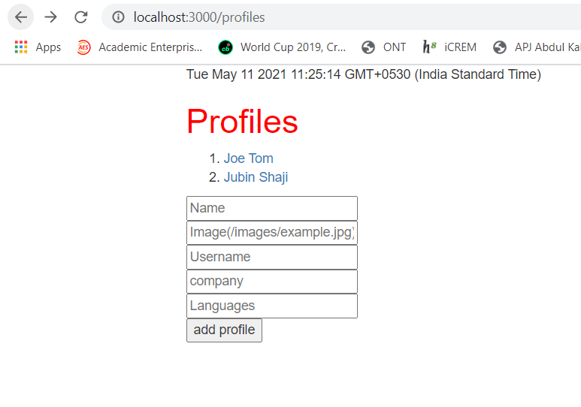

If we click on any one of the profiles shown it will redirect to the profile of each person.

Timestamp added in each page using middleware function

